Official Sensitive Statistics until 9:30am on 30 June 2015

Index of Services, April 2015


Date: 30 June 2015
Coverage: UK
Geographical Area: UK
Theme: Economy
Frequency: Monthly

Main points

- The Index of Services is estimated to have increased by 2.8% in April 2015 compared with April 2014. All of the 4 main components of the services industries increased in the most recent month compared with the same month a year ago.
- The largest contributions came from: business services and finance, which contributed 1.2 percentage points to total growth; and distribution, hotels and restaurants, which contributed 0.9 percentage points to total growth.
- The latest Index of Services estimates show that output increased by 0.2% between March 2015 and April 2015, following an increase of 0.1% between February 2015 and March 2015.
- The Index of Services increased by 0.4% in Quarter 1 (Jan to Mar) 2015 compared with Quarter 4 (Oct to Dec) 2014. This figure was unrevised from the estimate of 0.4% used in the Second Estimate of GDP, published on 28 May 2015 and is consistent with the Quarterly National Accounts, published on 30 June 2015.
- The figures within this release are estimates and are on a seasonally adjusted basis. The earliest period open for revision in this release is January 2014.

Understanding the Index of Services (IoS)

About the IoS

The monthly IoS provides a timely indicator of growth in the output of the services industries. The IoS is an important economic indicator and shares exactly the same industry coverage as the corresponding quarterly series within UK gross domestic product (GDP). The primary purpose of the IoS is to produce a short-term measure of the output of the services industries within the UK economy and show the monthly movements in the gross value added (GVA) of the service industries (2007 Standard Industrial Classification (SIC 2007) sections G to T).

The 4 main components of the services industries are:

- distribution, hotels and restaurants
- transport, storage and communication
- business services and finance
- government and other services

The IoS is the largest contributor to the output approach to the measurement of GDP, accounting for 78.4% of UK GDP in 2011.

All data in this bulletin are seasonally adjusted estimates and have had the effect of price changes removed (in other words, the data are deflated). Further information on some of the main concepts (including seasonal adjustment and deflation) underlying the estimates can be found in background note 10.

The quality of the IoS

The IoS is published around 8 weeks after the end of the reference month. There is no simple way of measuring the accuracy of the IoS, that is, the extent to which the estimate measures the underlying “true” value of the output growth (of the services industries) in the UK for a particular period. All estimates, by definition, are subject to statistical uncertainty and for many well-established statistics the Office for National Statistics (ONS) measures and publishes the sampling error associated with the estimate, using this as an indicator of accuracy. However, as IoS is constructed from a wide variety of data sources, some of which are not based on random samples, we don’t publish a measure of the sampling error associated with the IoS.

Reliability is one dimension of measuring accuracy, using evidence from analyses of revisions to assess the closeness of early estimates to subsequent estimated values. Revisions are an inevitable consequence of the trade-off between timeliness and accuracy. Figures for the most recent months are provisional and subject to revision in light of:

- late responses to surveys and administrative sources
- forecasts being replaced by actual data
- revisions to seasonal adjustment factors, which are re-estimated every month and reviewed annually

Revisions to the IoS are typically small (around 0.1 to 0.2 percentage points), with the frequency of upward and downward revisions broadly equal. More information on the most recent revisions analysis can be found in the component analysis section and in background note 15.

It should be noted that care should be taken when using the month-on-month growth rates, due to their volatility (background note 9).

Further information on the quality of the IoS is available in the Quality of the IoS report on the Index of Services Methods web page on our website. It should be noted that as part of the IoS industry review process, we are continually working on methodological changes to improve the accuracy of the IoS.

Main information
Table 1: Index of services main information, April 2015
UK
Percentage change
 |  | Index number (2011=100) | Most recent month on a year earlier | Most recent 3 months on a year earlier | Most recent month on previous month | Most recent 3 months on previous 3 months
Index of services |  | 109.4 | 2.8 | 3.0 | 0.2 | 0.5
Source: Office for National Statistics

The Index of Services (IoS) measures the quantity of output from all UK services industries, which account for more than three-quarters of the output approach to the measurement of gross domestic product. Index values are presently referenced to 2011 so that the average for 2011 is equal to 100. Therefore, an index value of 110 would indicate that output is 10% higher than the average for 2011.

As seen in Figure 1, the IoS increased by 2.8% in April 2015 compared with April 2014. In order of their contribution to growth (listed in reference table IOS1):

- business services and finance increased by 3.0%
- distribution, hotels and restaurants increased by 5.1%
- transport, storage and communication increased by 3.6%
- government and other services increased by 0.6%

Further detail on these movements can be found in the component analysis section.

Figure 1: IoS contributions¹ to the month-on-month a year ago percentage change, April 2015
UK
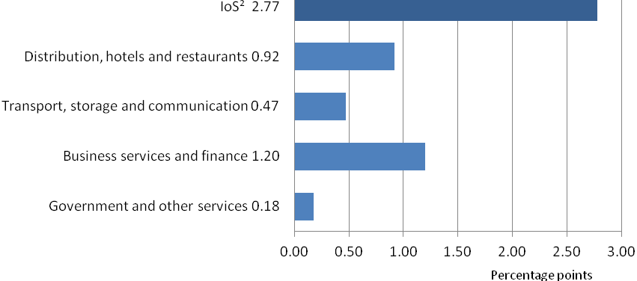
Source: Office for National Statistics
1. Individual contributions may not sum to the total due to rounding.
2. Percentage change.

Between March 2015 and April 2015, as seen in Figure 2, the IoS increased by 0.2%.

Out of the 4 main components of the services industries, 2 increased in the most recent month compared with the previous month. In order of their contribution to growth (listed in reference table IOS1):

- distribution, hotels and restaurants increased by 0.9%
- transport, storage and communication increased by 0.6%

Business services and finance remained flat with a change of 0.0%, but made a slight downward contribution due to unrounded data being slightly negative. In contrast, government and other services decreased by 0.1%.

More detail on individual components can be found in the IOSCOMP tables in the data section of this bulletin. The tables also provide information on the growth for the 3 months ending in April 2015 compared with the previous 3 months and compared with the 3 months ending April 2014.

Figure 2: IoS contributions¹ to the month-on-month percentage change, April 2015
UK
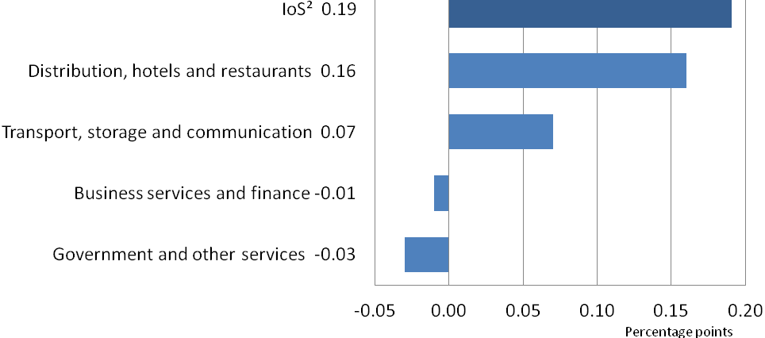

Source: Office for National Statistics
1. Individual contributions may not sum to the total due to rounding.
2. Percentage change.

Economic background

Total services grew by 3.1% between Quarter 1 (Jan to Mar) 2014 and Quarter 1 (Jan to Mar) 2015, and by 0.4% between Quarter 4 (Oct to Dec) 2014 and Quarter 1 (Jan to Mar) 2015. This is compared with growth rates of 2.9% and 0.4% for the economy as a whole.

Historically, the services industries have grown at a faster rate than all other headline industries. While GDP has grown at an average compound annual rate of 2.0% since 1997, services has grown at an average compound annual rate of 2.8% (more information can be found in Quarterly National Accounts). This has led to a continuing re-orientation of the economy towards services, despite productivity in the services industries rising more slowly than in the production industries (and manufacturing in particular) since 1997 (more information can be found in Labour Productivity, Quarter 4 (Oct to Dec) 2014). The higher output growth, therefore, reflects the increasing share of the labour force employed in services, which grew from 73% to 79% between 1997 and 2014 (Labour Market Statistics, June 2015, reference table EMP13).

Figure 3 shows the share of gross value added accounted for by services in the UK and in other G7 economies (more information on data for France, Germany, Italy Japan and the USA can be found on the Organisation for Economic Co-operation and Development (OECD) website). In 1997 the share of gross value added accounted for by services in the UK was just under 70%, around the middle of the range relative to the other G7 economies. By 2013 its share had risen to almost 80%, therefore the UK economy has become the most reliant on services among the G7 countries considered.

Figure 3: Services as a percentage of total gross value added in comparable economies to the UK

1997 to 2013
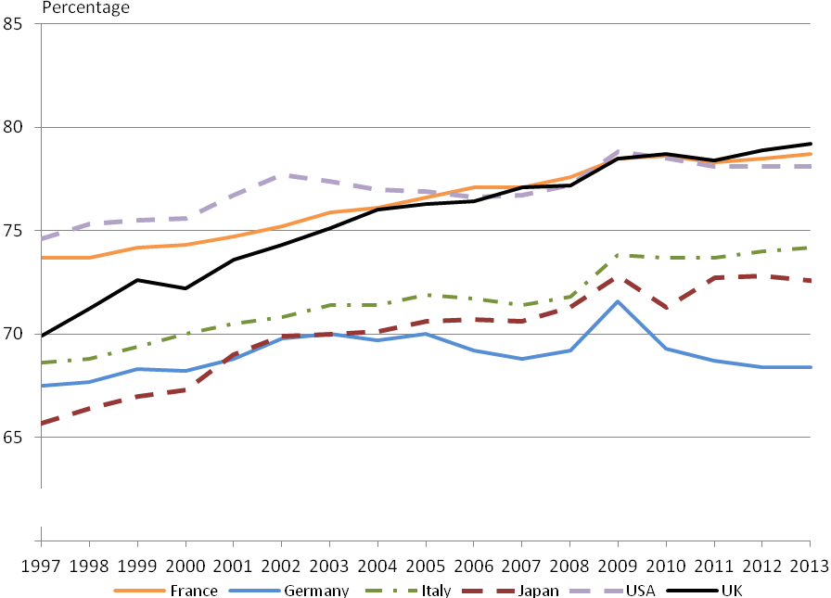

Source: Office for National Statistics, Organisation for Economic Co-operation and Development

In addition to strong long-run growth, the services industries were also less affected by the downturn in 2008 than other industries, such as production and construction, and subsequently recovered more quickly. The services industries have been mainly responsible for the recovery of the economy as a whole, being the only industry grouping to have surpassed its pre-downturn peak.

We have looked at the growth rates of the different industry groupings since 1997 in previous releases of the Index of Services.

GDP impact and components

With a weight of 78.4%, the services industries are the largest industrial grouping in the output approach to measuring GDP. The releases for the short-term economic indicators that feed directly into the output approach to measuring GDP include a table detailing growth in the 4 main industrial groupings (Table 2). This will aid understanding of the relationship between the individual short-term releases and GDP output.

In Quarter 1 (Jan to Mar) 2015, GDP was estimated to have increased by 0.4% compared with the previous quarter. The contribution an industry grouping makes to the GDP quarterly growth is dependent on the quarterly change in that industry grouping and its weight within the output approach to measuring GDP.
Figure 4: GDP contribution¹ to the quarter-on-quarter percentage change, Quarter 1 (Jan to Mar) 2015
UK
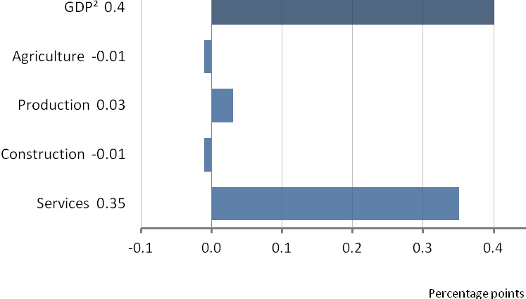
Source: Office for National Statistics
1. Contributions are to output gross value added and therefore may not sum to the percentage change in GDP. More information on the difference between the 2 measures can be found in the Short Guide to National Accounts.
2. Percentage change to 1 decimal place.

Monthly estimates are produced for each industrial grouping except agriculture. The April 2015 estimates for production and construction were published on 10 June 2015 and 12 June 2015 respectively. Quarterly National Accounts for Quarter 1 (Jan to Mar) 2015 was published on 30 June 2015, alongside this bulletin.

Table 2: GDP output component tables, Quarter 1 (Jan to Mar) 2015, chained volume measure, seasonally adjusted

UK
Publication
% of GDP | Release date | Period of GDP | Most recent quarter on a year earlier | Most recent quarter on previous quarter | Most recent month on the same month a year ago | Most recent month on previous month
Index of Production | 14.6 | 10 June | April 2015 | .. | .. | 1.2 | 0.4
 |  |  | Q1 2015¹ | 1.0 | 0.4 | .. | ..
 |  |  | Q4 2015² | 1.3 | 0.2 | .. | ..
Construction output | 6.4 | 12 June | April 2015 | .. | .. | 1.5 | -0.8
 |  |  | Q1 2015 | 4.4 | -0.2 | .. | ..
 |  |  | Q4 2015 | 8.9 | 0.2 | .. | ..
Index of Services | 78.4 | 30 June | April 2015 | .. | .. | 2.8 | 0.2
 |  |  | Q1 2015 | 3.1 | 0.4 | .. | ..
 |  |  | Q4 2015 | 3.4 | 0.9 | .. | ..
Retail Sales |  | 18 June | April 2015 | .. | .. | 4.6 | 0.9
 |  |  | Q1 2015 | 5.3 | 0.9 | .. | ..
 |  |  | Q4 2015 | 5.1 | 2.3 | .. | ..
Agriculture | 0.6 |  | Q1 2015 | 2.5 | -2.3 | .. | ..
 |  |  | Q4 2015 | 10.2 | 1.2 | .. | ..

Source: Office for National Statistics
1. Q1 is Quarter 1 (Jan to Mar)
2. Q4 is Quarter 4 (Oct to Dec)
3. No data represented by ..

Component analysis

Table 3: Growth rates and contributions¹ to the Index of Services, April 2015

UK
Percentage change
Description | % of services | Month on a year earlier volume (SA²) (%) | Contribution to services (% points) | Month on month growth volume (SA) (%) | Contribution to services (% points)
Total services industries | 100 | 2.8 | 2.8 | 0.2 | 0.2
Distribution, hotels and restaurants | 18 | 5.1 | 0.9 | 0.9 | 0.2
Transport, storage and communication | 13 | 3.6 | 0.5 | 0.6 | 0.1
Business services and finance | 39 | 3.0 | 1.2 | 0.0 | 0.0
Government and other services | 30 | 0.6 | 0.2 | -0.1 | 0.0
Source: Office for National Statistics
1. Individual contributions may not sum to the total due to rounding.
2. SA = seasonally adjusted.

Distribution, hotels and restaurants
The index of distribution, hotels and restaurants increased by 5.1% in April 2015 compared with April 2014, following an increase of 4.0% in March 2015 compared with the same month a year earlier. The main contributors to the increase were: retail trade, except of motor vehicles and motorcycles, which rose by 4.5%; wholesale and retail trade and repair of motor vehicles and motorcycles, which rose by 7.6%; and wholesale trade, except of motor vehicles and motorcycles, which rose by 3.7%.

Transport, storage and communication
The index of transport, storage and communication increased by 3.6% in April 2015 compared with April 2014, following an increase of 4.2% in March 2015 compared with the same month a year earlier. The main contributors to the increase were: computer programming, consultancy and related activities, which rose by 5.3%; land transport, which rose by 6.2%; and publishing audiovisual and broadcasting activities, which rose by 2.9%.

Business services and finance
The index of business services and finance increased by 3.0% in April 2015 compared with April 2014, following an increase of 3.4% in March 2015 compared with the same month a year earlier. The main contributors to the increase were: other professional service activities, which rose by 6.4%; administrative and support services activities, which rose by 5.5%; and real estate activities, which rose by 2.3%.

Government and other services
The index of government and other services increased by 0.6% in April 2015 compared with April 2014, following an increase of 0.9% in March 2015 compared with the same month a year earlier. The main contributors to the increase were: human health and social work activities, which rose by 2.1%; activities of households as employers of domestic personnel, which rose by 13.1%; and other service activities, which rose by 1.8%.

Revisions
The Index of Services (IoS) follows the National Accounts Revisions policy. Revisions are caused by a number of factors including, but not limited to:

- revisions to source data due to late responses
- actual data replacing forecast data
- revisions to seasonal factors that are re-estimated every period

More information on IoS revisions is available on the Index of Services Methods page.
We produce revisions triangles of services growth to provide users with one indication of the reliability of this main indicator. Statistical tests are performed on the average revision to test if it is statistically significantly different to 0. Further information can be found in background note 16.
In this release of data, the earliest period open to revision is January 2014. Across this open period, there are minimal revisions to the month-on-a-year ago and month-on-month growth rates. The growth rate for March 2015 compared with March 2014 was revised up by 0.1 percentage points from the previous estimate of 2.8%. However, the month-on-month growth rate for March 2015 compared with February 2015 (0.1%) was unrevised.

Further detail on the revisions to the IoS components can be found in the RIOS1 tables in the data section of this publication.

Industry spotlight: renting and leasing services

According to the UK Standard Industrial Classification 2007 (SIC 2007), renting and leasing services (industry 77) cover the renting or leasing of most non-financial assets (financial leasing and renting of real estate is included elsewhere in the accounts). Some of these assets are intangible, such as patents or mineral exploration rights, but the largest proportion of output can be attributed to the rental of tangible assets. Vehicle rental accounted for approximately 45% in 2014, but rental of other machinery is also an important part of the industry. A smaller proportion, around 6%, of the industry consists of renting sports and recreational equipment, such as canoes or beach umbrellas among other items.

The performance of the renting and leasing industry was similar to the entire service industries from 1990 to 2008, growing at an average compound annual rate of 3.7% relative to 3.2% for the entire services industries. However, since 2011, renting and leasing activities have increased sharply, growing by 34% in volume terms between 2011 and 2014. The majority of this increase can be attributed to vehicle rental and leasing. Output in this sub-industry may have been affected by the availability of a number of alternative finance schemes which could have made leasing a car a more attractive option.

Figure 5: Index of services and renting and leasing activities

UK, 1990 to 2015
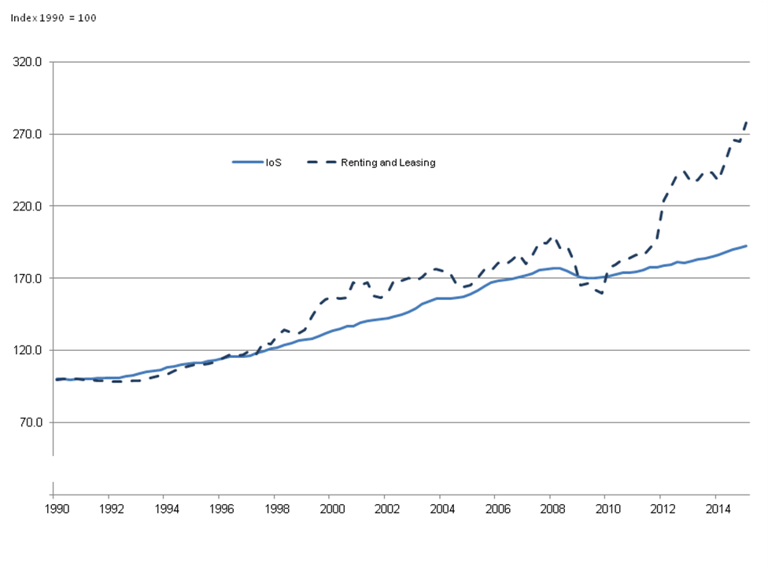
Source: Office for National Statistics

A large part of this industry consists of renting and leasing of equipment that can be used in the production of goods or services, such as crane lorries, or office equipment. Businesses may decide that this is a good alternative to investing in their own capital; renting and leasing of this kind of equipment has been growing faster than total investment (as measured by gross fixed capital formation, Quarterly National Accounts) since 1997.

This may provide more flexibility for firms, if the type of assets they need in the production process is liable to change. For example, the industry which utilises the most renting and leasing as intermediate consumption is the construction industry, which accounted for 33% of intermediate consumption demand in 2012 (Input-Output Supply and Use tables, 2014 edition). This is an industry that is generally accepted to be largely project-based, so it may often make more sense to rent equipment as appropriate, rather than invest in assets that may not be suitable for future projects.

Background notes

What’s new
To improve availability of monthly services data, additional lower level series will be published at 9:30am alongside the IoS release. Data will be available at approximately the 2 digit level of the UK Standard Industrial Classification on a seasonally adjusted chained volume measure basis.

Following the recent assessment by the UK Statistics Authority covering short-term economic output indicators, the Index of Services (IoS) has been re-designated as a National Statistic. A letter of confirmation was published on 26 March 2015 and is available on the assessment reports web page on our website (report number 278).

Continuous improvement of GDP: sources, methods and communication
The GDP Output Improvement Report, published on 30 September 2014, provides a detailed update of the implementation of improvements for Blue Book 2014, progress on industry reviews and wider cross-cutting improvements, a comprehensive timetable for the industry review project, an update of industry quality ratings and progress on experimental statistics. It also features sections on deflation and annual coherence adjustments to improve the understanding and transparency of the methods involved in producing Index of Production (IoP), IoS, and GDP(O).

Assessment reports by the UK Statistics Authority are available on our website for the output approach to measuring GDP and the short-term indicators that feed into it. Furthermore, the priorities for national accounts production and development over a 5 year period (financial year ending 2014 to financial year ending 2018) are highlighted in the National Accounts and Related Statistics Work Plan and an independent review of the UK's national accounts and balance of payments has been produced as part of our programme of National Statistics Quality Reviews (NSQRs).

In September 2014, the industry review timetable was published as part of the GDP(O) Improvement Report stating that during July 2015, 4 industry reviews would be published. However, the publication of these reviews will now be delayed. The 4 industry reviews are:

- professional services

- water transport

- social care

- post and courier services

The national accounts (NA) work plan will be published early summer, outlining future priorities for NA and this project. An update to users will follow the agreement of the NA work plan and will provide further information of the progress of industry reviews. Should you have any queries please contact us at STOI.Development@ons.gov.uk.

In light of the Index of Services retaining the National Statistics branding in March 2015, progress can now be made on removing the “experimental statistics” label for the remaining 17 industries that still carry it. A list of the industries with “experimental statistic” label can be found in the Index of Services - Industry Reviews report published August 2012.
The Code of Practice for Official Statistics defines experimental statistics as "new official statistics undergoing evaluation".

Details on the reasons why the 17 industries have an experimental label can found in the August 2012 and September 2014 IoS and GDP(O) Improvement reports. It is proposed that in September 2015, we will remove the “experimental statistics” label on the 17 industries and move them to “official statistics” status. Details on the process can be found in the guide to experimental statistics - frequently asked questions.

These industries will be subject to review by the UK Statistics Authority during the next assessment of the IoS to decide if they should be given “National Statistic” status.

Should users have any comments regarding these industries moving from experiment to official statistic status they should contact the Short-term Output Indicators Development branch at STOI.Development@ons.gov.uk by 31 July 2015.

What do you think?
As a user of our statistics we would welcome your feedback on this publication. If you would like to get in touch please contact us via email: ios.enquiries@ons.gsi.gov.uk.

Special events
We maintain a list of candidate special events in the Special Events Calendar. As explained in our Special Events policy, it is not possible to separate the effects of special events from other changes in the series.

Understanding the data

Short guide to the Index of Services

The Index of Services shows the monthly movements in the gross value added (GVA) of the service industries (2007 Standard Industrial Classification (SIC 2007) sections G to T). These industries account for around 78% of gross domestic product (GDP) in 2011. The index is estimated using the same data sources and national accounts methodology as the quarterly estimate of services industries’ gross value added within the output approach to measuring GDP (GDP (O)). These consist of the distribution, hotels and restaurant industries (SIC 2007 sections G and I); transport, storage and communication (sections H and J); business services and finance (sections K to N); and government and other services (sections O to T).

International comparison

International comparison with the IoS is difficult, as most comparable economies don’t produce equivalent estimates. Eurostat turnover in services estimates are not comparable with the IoS, as they exclude the wholesale and retail trade; furthermore, most of the estimates are only available quarterly. The USA also produces services output estimates, but only on a quarterly basis, with a 4 month lag time. Japan has a direct equivalent of the IoS, but the estimates are not seasonally adjusted. The closest equivalent estimates are from Canada, which produces a monthly output estimate of GDP with a breakdown by industry (including an aggregate for services). There are also comparable quarterly estimates from Sweden and Ireland.

Short guide to national accounts

The national accounts provide an integrated description of all economic activity within the economic territory of the UK, including activity involving both domestic units (that is, individuals and institutions resident in the UK) and external units (those resident in other countries). In addition to being comprehensive, the accounts are fully integrated and internally consistent. More information can be found in UK national accounts: a short guide.

How our statistics explain the economy
The IoS is mentioned in a video summary which highlights 14 ways ONS statistics help you understand the economy. The video summary, along with an interactive version of the video, was released on our website on 27 June 2014, alongside Quarterly National Accounts for Quarter 1 (Jan to Mar) 2014.

Interpreting the data

Some monthly data are volatile. When looking at growth rates, the headline IoS figures focus on the percentage change between the most recent month-on-a-year earlier and the most recent 3 months-on-a-year earlier.

The monthly Index of Services statistical bulletin is usually published on the same days as the Gross Domestic Product Preliminary Estimate statistical bulletin, the Second Estimate of Gross Domestic Product statistical bulletin or the Quarterly National Accounts statistical bulletin.

The data for the IoS in this statistical bulletin are generally consistent with Quarterly National Accounts for Quarter 1 (Jan to Mar) 2015, published on 30 June 2015. However, rounding can sometimes cause differences between the 3-monthly growth rates presented in this release, compared with the quarterly growth rates presented in Quarterly National Accounts. Data for the retail industry are broadly comparable with the Retail Sales release, published on 18 June 2015, but as the 2 series operate under different revisions policies, there can be timing differences in the updating of the 2 series. Also, adjustments to the data within the IoS release are sometimes made at the time of the Blue Book to improve the coherence of the 3 approaches to measuring GDP. Therefore, inconsistencies between the 2 series are not unusual but tend to be small. There are also conceptual and coverage differences between retail sales and retail output which can lead to apparent inconsistencies.

Definitions and explanations
Definitions found within the main statistical bulletin are listed:

Index number
An index number is a number which indicates the change in magnitude relative to the magnitude at a specified point, the latter usually taken as 100. For example, the level of services for April 2015 is given in Table 1 as 109.4. This means that services output was 9.4% higher than the average in the reference period, which is currently 2011.

Seasonal adjustment
The index numbers in this statistical bulletin are all seasonally adjusted. This aids interpretation by removing annually recurring fluctuations, for example, due to holidays or other regular seasonal patterns. Unadjusted data are also available.
Seasonal adjustment removes regular variation from a time series. Regular variation includes effects due to month lengths, different activity near particular events such as shopping activity before Christmas, and regular holidays such as the May bank holiday.
Some features of the calendar are not regular each year, but are predictable if we have enough data, for example, the number of certain days of the week in a month may have an effect, or the impact of the timing of Easter. As Easter changes between March and April, we can estimate its effect on time series and allocate it between March and April depending on where Easter falls. Estimates of the effect of the day of the week and Easter are used respectively to make trading day and Easter adjustments prior to seasonal adjustment.

X-13-ARIMA-SEATS is the current seasonal adjustment software used for the IoS.

Value (current price)
Economic transactions involve the production of goods and the sale of goods and services (commodities). The monetary value (or current price) of these transactions is a product of the quantity produced or sold and the unit price. In a particular period, the total (aggregate) value of all transactions taking place in the economy is simply the sum of the individual transaction values in that period. The current price is sometimes referred to as the “nominal” price.

Volume (constant price)
When it comes to comparing the difference in aggregate values between 2 time periods, the observed movement is generally a combination of changes in quantity and changes in price. In a lot of cases, the interest of users of economic data lies in understanding the degree to which economic growth is being driven by changes in quantities (that is, physical volumes of production and consumption). It is standard practice to present many economic statistics as volume series (showing changes in the level of the series that have not been affected by changes in price) and such series are referred to as “at constant prices” or “real” prices.

Deflation

The process of removing price changes from a value series and converting to a volume series is known as deflation. All index numbers presented in this bulletin are volume measures and have had the effect of price changes removed.

Chained volume measures
The indices in this bulletin are presented as “chained volume” measures, meaning that successive volume estimates have been linked (or chained) together. Annual chain-linking was introduced in 2003 and is considered preferable to producing standard volume series, as chained volume measures more accurately reflect volume changes over time. More information on chain-linking can be found in the Tuke and Reed (2001) article, and a paper on chain-linking weights in the output approach to measuring GDP can be found on the Methods and Sources page.

Gross domestic product (GDP)

The total value of production activity in the economic territory. It is the balancing item on the production account for the whole economy. Domestic product can be measured gross or net of consumption of fixed capital (or depreciation). It is presented in the accounts at
market (or purchasers’) prices. A further distinction is that it can be at current prices or chained volume measures.

Methods

Index of Services methodology can be found on our website.

Composition of the data
The IoS uses a wide variety of different data, from many sources, which are produced on either an annual, quarterly or monthly basis.
Some of the indicators are derived using current price turnover deflated by a suitable price index. This includes data from the monthly business survey (MBS): an ONS short-term survey on different parts of the economy. It is one of the main data sources used in the compilation of the IoS.
More information on monthly business survey data can be found within the Economic and Labour Market Review release.
Other sources use direct volume measures that don’t need to be deflated, such as Civil Aviation Authority data for air transport. Other proxies, such as employment numbers, are also used. This is the case with Public Sector Employment and Workforce Jobs data.
Where monthly data are not available (for example, when data are delivered quarterly or annually), monthly estimates are derived by forecasting data. This is done using the X-13-ARIMA-SEATS forecasting method and interpolating a monthly path using a cubic spline.
An X-13-ARIMA-SEATS forecast is also used where actual data at industry level are not available for the latest period (a lower proportion of actual data are available for the latest month). When the forecast is replaced by actual data, this may lead to revisions to the published data.
The IoS adheres to the Government Statistical Service Disclosure Control Policy. More information can be found in the Quality and Methodology Information (QMI) report.
Response rates
Approximately 42% of the IoS estimates are based on data collected via our Monthly Business Survey (MBS). In addition, approximately 7% of the IoS estimates are collected via our Retail Sales Inquiry (RSI). The remainder is based on data received from other ONS sources and external data sources. The MBS and RSI response rates for data included in this publication are presented for the current months and the 3 months prior in Table 4. The response rates for the previous periods are updated to reflect the current level of response, incorporating data from late returns. There are 2 response rates included; the first is a percentage of the sampled turnover returned and the other is a percentage of the amount of questionnaire forms returned.

Table 4: Survey response rates, April 2015
UK
 |  |  |  | Response rate (%)
Period | Jan 2015 | Feb 2015 | Mar 2015 | Apr 2015
Monthly Business Survey (Services)
Turnover | 95.5 | 97.0 | 94.4 | 87.7
Questionnaire | 86.3 | 84.9 | 81.7 | 74.8
Retail Sales Inquiry
Turnover | 98.9 | 97.5 | 98.3 | 89.1
Questionnaire | 76.4 | 77.2 | 76.8 | 74.5
Source: Office for National Statistics

Historical MBS response rates for the services industries as at the time of the relevant publication are also available back to 2010.

Basic quality information
Some general information on the quality of the Index of Services (IoS) can be found in the “Understanding the Index of Services” section in the main part of this statistical bulletin.

Additionally, a Quality and Methodology Information (QMI) report for the IoS was published on 11 February 2015. The report pulls together qualitative information on the 5 Eurostat criteria of quality: relevance, accuracy, timeliness and punctuality, accessibility and clarity, and comparability and coherence, and provides a summary of the methods used to compile the IoS output, describing the strengths and limitations of the estimates produced.

Further quality information, including details of the quality adjustments process for IoS, was published on 31 October 2014 and can be found on the Index of Services Methods page on our website.

National accounts revisions policy

Main documentation explaining the national accounts revisions policy is available.

Revisions triangles

SIC 2007 revisions triangles are contained in a zip folder. This folder can be found within the data section of this bulletin.

Revisions to data provide one indication of the reliability of main indicators. A statistical test has been applied to the average revision to find out if it is statistically significantly different from 0. An average revision close to 0 is desirable as it suggests that revisions are not predictable in any one direction. The result of the test is that the average revision is not statistically significantly different from 0.

Table 5 presents a summary of the differences published between April 2009 and April 2014 and the estimates published 12 months later.

Table 5: Revisions between first publication and estimates 12 months later

UK
 |  |  | Percentage change
 | Value in latest period | Average over the last 60 months | Average over the last 60 months without regard to sign (average absolute revision)
Index of Services 3 month on 3 month growth rate | 0.5 | -0.06 | 0.17
Index of Services 1 month on 1 month growth rate | 0.2 | -0.03 | 0.18
Source: Office for National Statistics

Publication policy

Details of the policy governing the release of new data are available from our media relations office. There is also a Pre Release Access List of those given pre-publication access to the contents of this release.

Accessing data

The data presented in the tables of this statistical bulletin are also available to download from the data section of this publication. A complete run of data is available as a time series dataset on our website.

We provide an analysis of past revisions in the IoS and other statistical bulletins; more information can be found in Revisions information in ONS First Releases.

Following ONS

You can follow us on Twitter and Facebook and view the latest podcasts on YouTube.

Code of Practice for Official Statistics

National Statistics are produced to high professional standards set out in the Code of Practice for Official Statistics. They undergo regular quality assurance reviews to ensure that they meet customer needs. They are produced free from any political interference.
The UK Statistics Authority has designated these statistics as National Statistics, in accordance with the Statistics and Registration Service Act 2007 and signifying compliance with the Code of Practice for Official Statistics.

Designation can be broadly interpreted to mean that the statistics:
• meet identified user needs;
• are well explained and readily accessible;
• are produced according to sound methods and;
• are managed impartially and objectively in the public interest.

Once statistics have been designated as National Statistics it is a statutory requirement that the Code of Practice shall continue to be observed.

Details of the policy governing the release of new data are available by visiting www.statisticsauthority.gov.uk/assessment/code-of-practice/index.html or from the Media Relations Office email: media.relations@ons.gsi.gov.uk

Copyright

© Crown copyright 2015

You may use or re-use this information (not including logos) free of charge in any format or medium, under the terms of the Open Government Licence. To view this licence, visit

www.nationalarchives.gov.uk/doc/open-government-licence/ or write to the Information Policy Team, The National Archives, Kew, London TW9 4DU.

This document is also available on our website.

Next publication: Tuesday 28 July 2015

Issued by: Office for National Statistics, Government Buildings, Cardiff Road, Newport NP10 8XG

Media contact:

Media Relations office +44 (0) 845 6041858

Emergency on-call +44 (0)7867 906553

Email media.relations@ons.gsi.gov.uk

Contact us:
+44 (0)845 6013034
info@ons.gsi.gov.uk

